Google Docs

Purpose: allows you to create documents, share, edit and submit electronically while storing safely on the cloud. It also allows you to create classroom folders for your individualized classes.

- Students need to go to the BBCHS.org website and click “Student Gmail”.
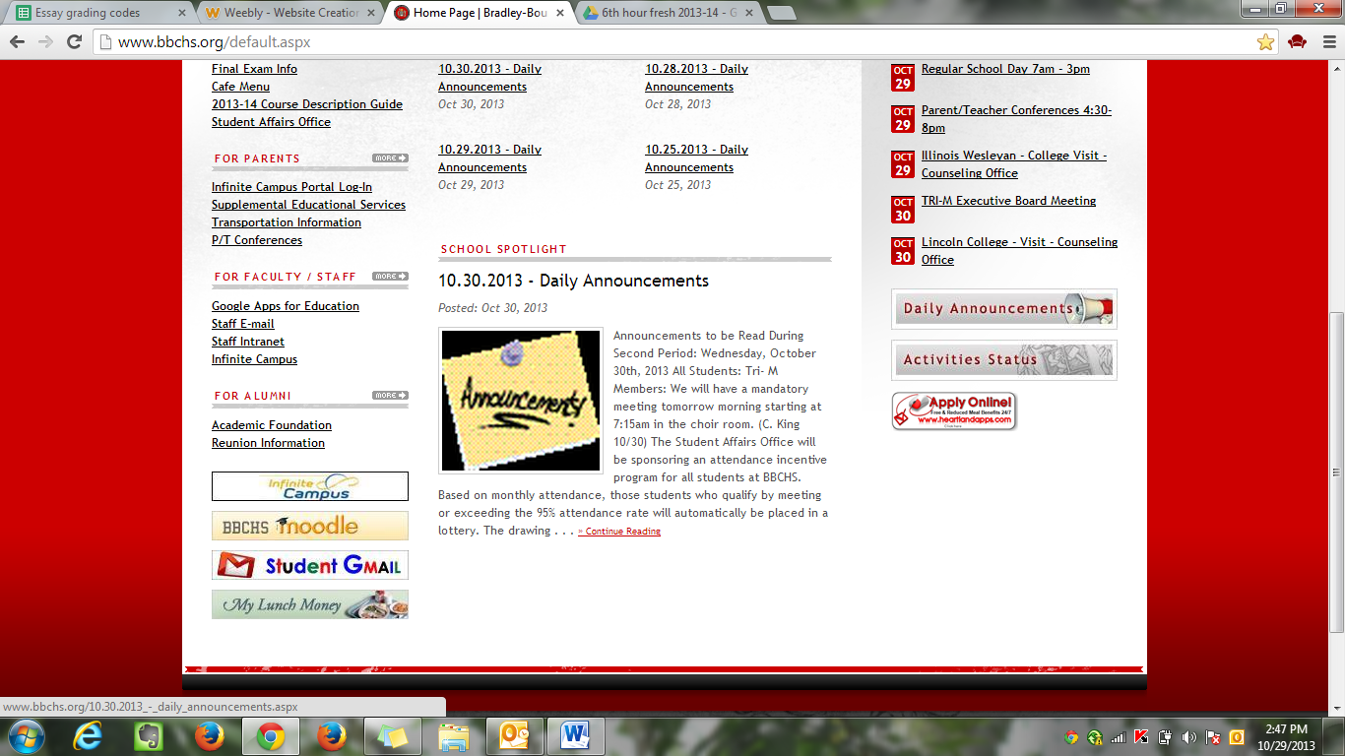
Login: lastname.firstname
Password: same as network

- Open “Drive”
Then, click “Create” chose “Folder”

- Title folder “Last name, First Name Eng. Hour”
For example: DiGiorgio, Kristen Eng. 5th hour

- Next, Right click the folder, click “share” and type in Teacher’s name. Be sure to unclick “notify people via email”

- Every document you create, you need to allow access to “edit” for your teacher.
- Everything you do for English class to submit/want me to view, it must be put in this folder.

