Google Docs

Purpose: allows you to create documents, share, edit and submit electronically while storing safely on the cloud. It also allows you to create classroom folders for your individualized classes.

1. Students need to go to the BBCHS.org website and click “Student Gmail”.

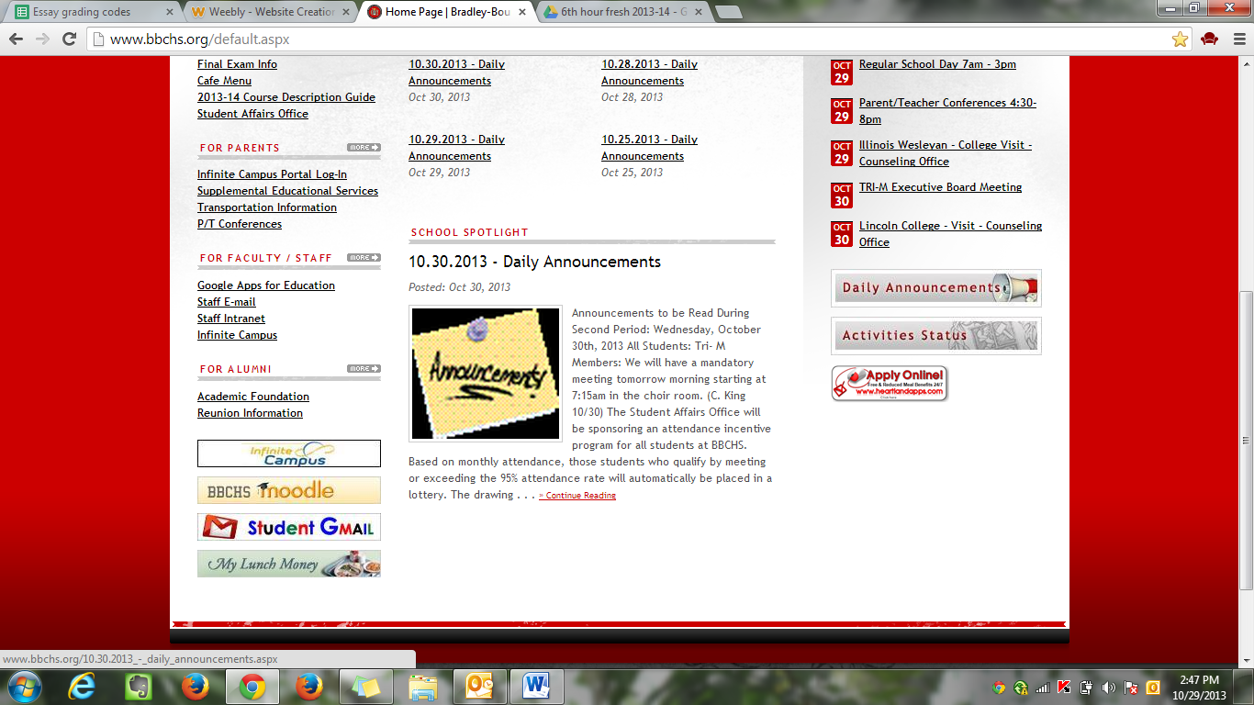

Login: firstname.lastname

Password: same as network

1. Open “Drive”

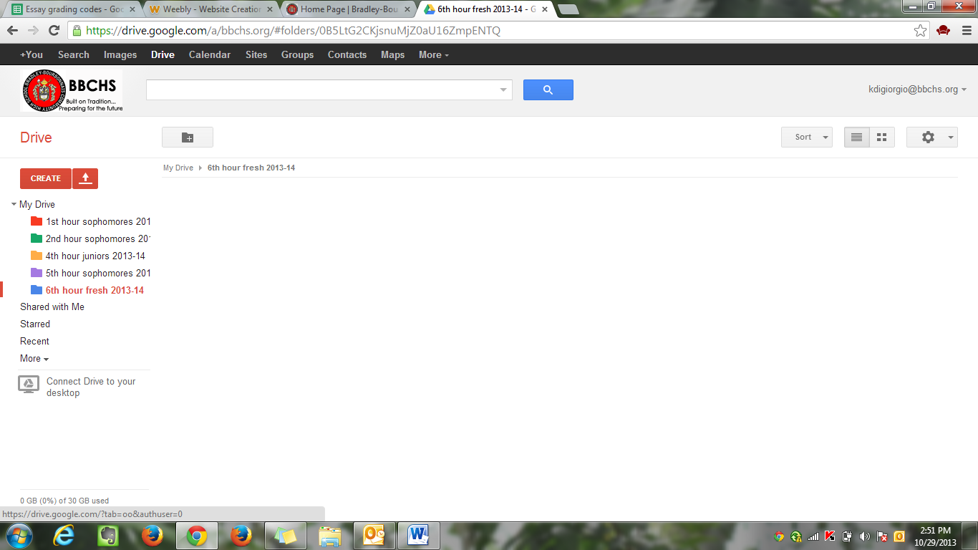Then, click “Create” chose “Folder”

1. Title folder “Last name, First Name Eng. Hour”

*For example: DiGiorgio, Kristen Eng. 5th hour*

1. Next, Right click the folder, click “share” and type in Teacher’s name. Be sure to unclick “notify people via email”

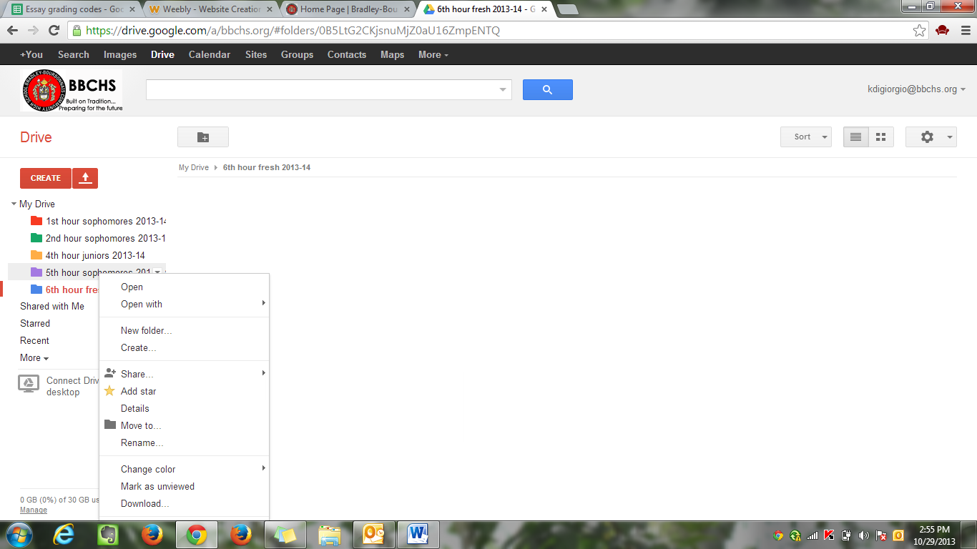

1. Every document you create, you need to allow access to “edit” for your teacher.
2. Everything you do for English class to submit/want me to view, it must be put in this folder.