Introduction
1/15/2015
DiGiorgio
LORD OF THE FLIES
Written by: William Golding

Enduring Understanding  - People’s ______________________________ are often stronger than their _____________ ones in creating human societies.  - Defect in ___________________ relate to defects in human nature.  - Novelists often use their fiction to make ______________ about their ______________ or ______________ beliefs.  - Theoretical frameworks offer solutions to ______________ and ____________ fiction and nonfiction works.  What does it mean to be human? Is evil an innate human quality?  Facts  - Most of the characters, actions, and objects ______________ larger ideas.  - Golding’s novel deals with the conflict between the _____________ mind and _______________ instinct.  - The novel takes place during a fictional _________________.  - A group of British schoolboys are flown out of their country to protect them from the horrors of war.  - ... however, the plane crashes, killing the____________on board.  - The boys remain stranded on a ________________________, left to fend for themselves.  - The entire novel takes place on this deserted tropical island.  Think about novels, short stories, news articles, TV shows, and films where people are on a tropical island. What kinds of things happen in these stories?  What do you know about Beelzebub?  - _  - _ | Additional notes space:  **The theoretical framework is the structure that can hold or support a theory of a research study.  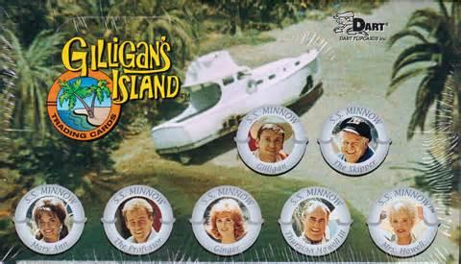  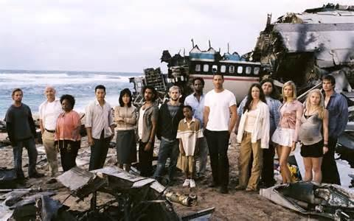  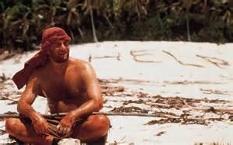  BEEZLEBUB  