Congratulations! You are ready to move on and prepare for your final speech!

Use your outline to help guide you.
Notecards:
- You may use up to 5 note cards total. Your note cards should not have everything written out, just main ideas/topics. You may, however, write out your evidence directly.
- Number and label the note cards exactly like the speech outline.
- Skip a line between each lettered item.
- Use keywords and phrases only. No complete sentences/paragraphs! ABBREVIATE!
- No more an 6 words per line.
- Put reminders for Visual Aid(s) (VA) and Nonverbals (NV) in the margins.
- Highlight important stuff.
- Don’t write on the back of the cards.
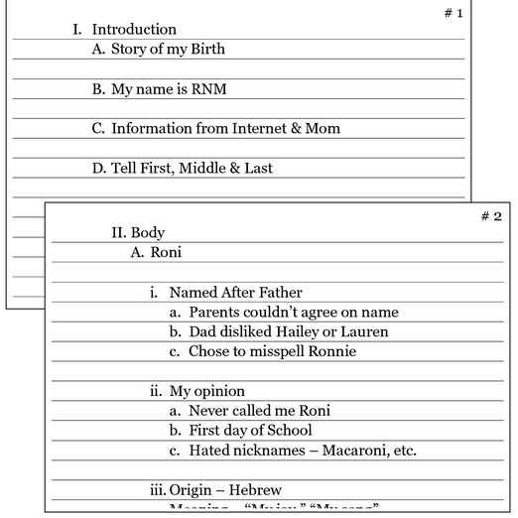
Visual Aid
- Create a visual aid similar to what you did for your “Favorite Thing” speech. You should have main points, supporting ideas and 2 graphics.
- Use no more than 6 words per bullet point & 6 bullet points total.
- Don’t use complete sentences, words and phrases only!
- Have at least 2 appropriate graphics to accompany your topic; this should enhance your speech.
- Make sure colors and font are clearly visible (for example, no yellow on blue).

