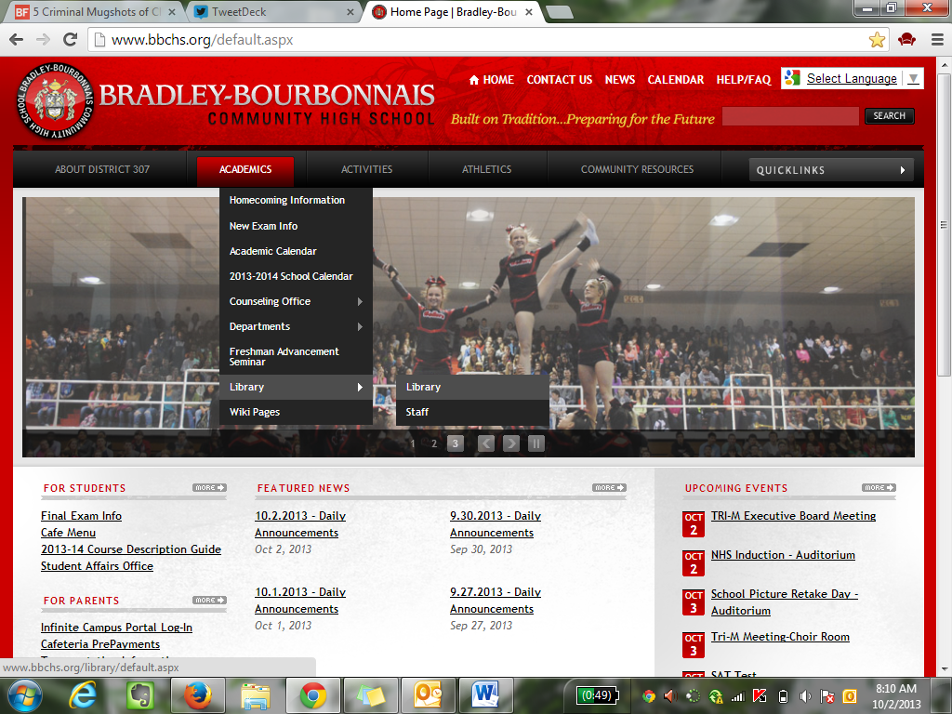

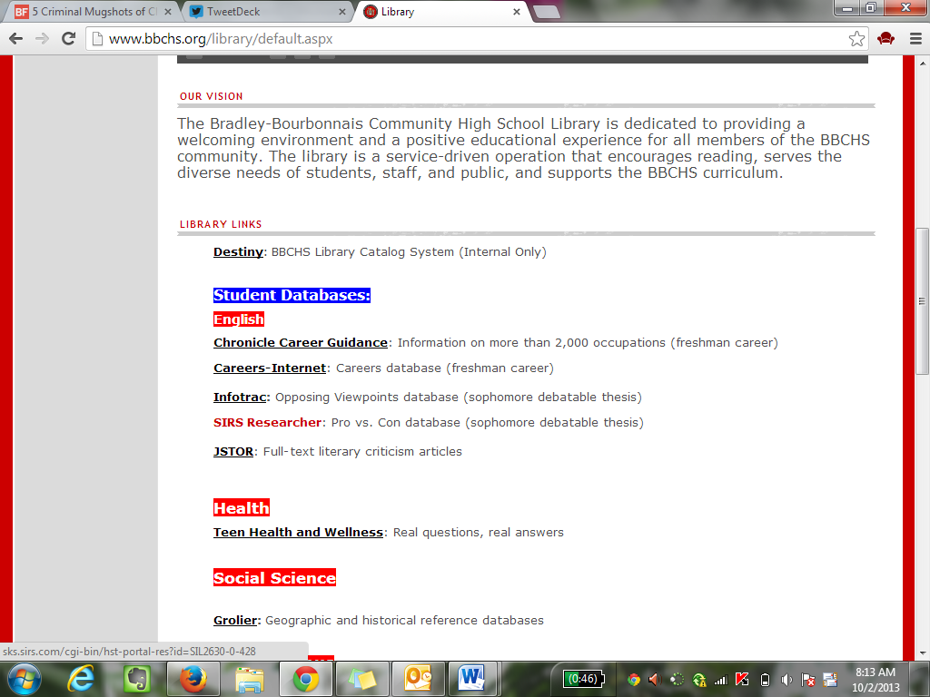
Go to SIRS Researcher

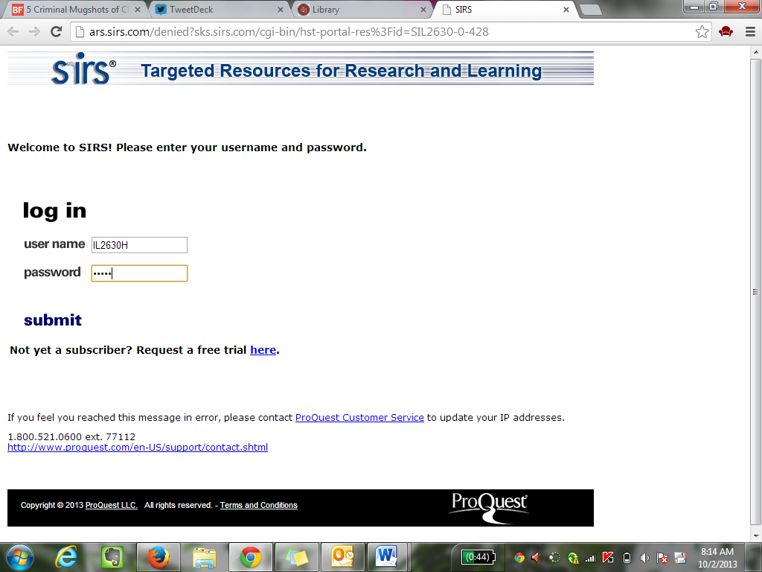
Username: IL2630H….that is a ZERO, not an “O”

Password: 60915

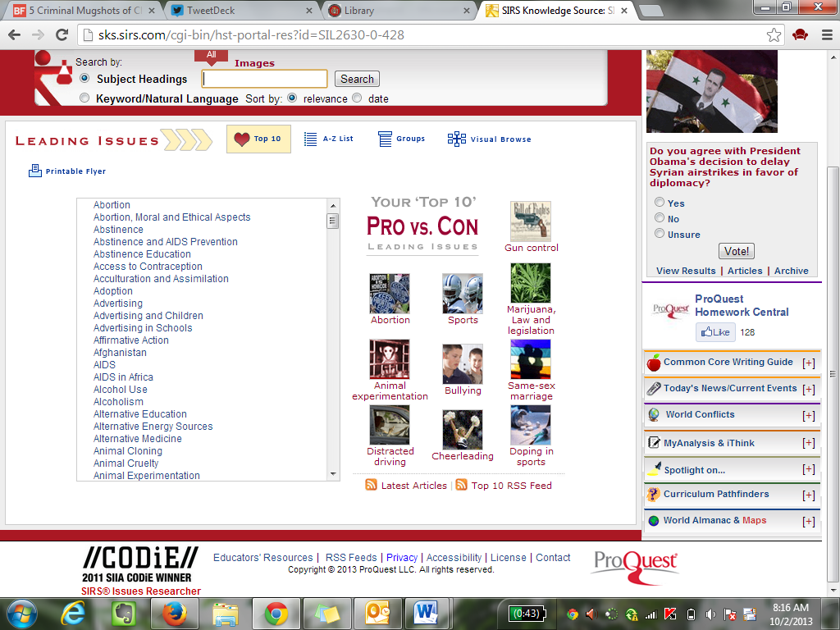

Start searching for your topic! You will want to find an article to PRINT and bring in. The “visual browse” option is nice if you are still unsure of your topic. If you know what topic you want to research, make sure you choose an article that supports the side of the topic you want to support!

